Leland Adams

**Homework 1**

1. Visit one of the stores that sells textbooks. For 10 or more textbooks, record the department abbreviation and the course number (for example ISM 6930), the price of a new textbook, and whether the book is required, recommended, or optional. Create and print a SAS dataset with this information. Turn in the program, the log file, and the output.

**CODE**

**data** books;

input Title $ **1**-**30** Department $ **32**-**35** Course $ **37**-**40** Price $ **42**-**51** Required $ **54** ;

datalines;

The Little SAS Book ISM 6930 $48.55 Y

COBOL for the 21st Century ISM 6930 $197.97 N

Fundamentals of Database ISM 4212 $125.22 O

Starting Out with Visual C# ISM 3232 $128.28 Y

Operations and Supply Chain ISM 6436 $217.11 O

Little Red Book of Selling MAR 3113 $9.99 O

Systems Analysis & Design ISM 3113 $58.50 N

Business Law BUS 3001 $90.36 Y

Project Management ISM 5432 $189.91 Y

Marketing Research MAR 3416 $218.66 O

**run**;

**proc** **print** data = books;

**run**;

**LOG**

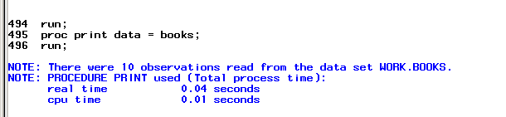

**OUTPUT**

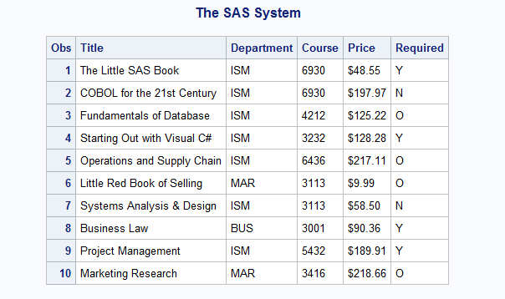

1. Find some soft-drink dispensing machines on campus. Record the following information about 10 or more beverages: Name the beverage, type of container dispensed (can, bottle, juice box, paper cup), price, and whether that drink was sold out when you visited the machine. Use SAS to create and print a dataset with this information. Turn in the program, the log file, and the output.

**CODE**

**data** soda;

input Name $ **1**-**13** Container $ **15**-**23** Price $ **23**-**29** Out $ **30**-**34**;

datalines;

Mellow Yellow Bottle $1.50 No

Coke Bottle $1.50 No

Monster Can $2.00 No

Sprite Bottle $1.50 No

Water Bottle $1.25 No

Fanta Bottle $1.50 No

Fuze Bottle $1.50 No

NOZ Can $2.00 No

Vanilla Coke Bottle $1.50 No

Diet Coke Bottle $1.50 No

;

**run**;

**proc** **print** data = soda;

**run**;

**LOG**

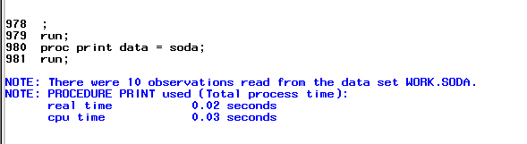

**OUTPUT**

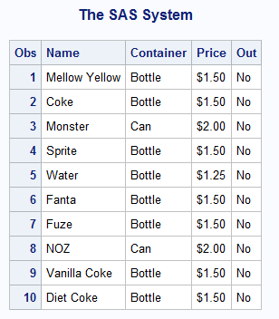

1. Get a copy of a local newspaper or the campus newspaper and find the advertisements for apartment housing in the classified section. Make and print a SAS dataset with the following information about 10 or more apartments: Number of bedrooms (usually abbreviated BR in the ads), number of bathrooms (abbreviated BA), monthly rent in dollars, and the phone number to call for more information. Turn in the program, the log file, and the output.

**CODE**

**data** rent;

input BD BA Price $ **6**-**14** Phone $ **16**-**28**;

datalines;

1 1 $1,220 888-366-4894

2 2 $1,550 877-351-1995

2 3 $1,350 813-241-5674

1 1 $870 813-555-1234

2 1 $950 813-567-0012

1 1 $780 813-456-2312

2 2 $1,200 888-760-5183

3 3 $2,000 888-784-3672

2 2 $1,400 813-546-8973

1 1 $1,300 813-245-6712

;

**run**;

**proc** **print** data = rent;

**run**;

**LOG**

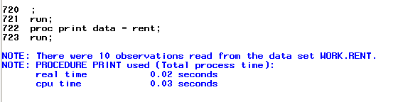

**OUTPUT**

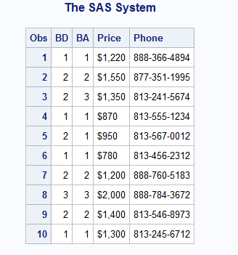

1. For each of the following terms, tell whether that term could be accepted by SAS as a *variable* name. If not, describe why SAS could not accept it.

* DOLLARS$ - will not accept due to dollar sign
* DIAMETER- yes
* 8Y- no names must start with a letter or underscore
* TREATMENT- yes
* _PPX4T_G- yes

1. For each of the following terms, tell whether that term could be used as the name of a SAS *dataset*. If not, tell why SAS could not use it.

* 1982DATA- will not accept must start with letter or underscore
* DATA#1- will not accept due to special characters
* D_A_T_A_ - yes
* TRIALDATA- yes
* BARNEY- Yes

1. The following passage appears on page 70 of High School Basketball Rules

It has been reported that when using computers to keep statistics, etc., the numbers 0 and 00 are treated as a single number. The action of the committee simply decrees that beginning in (the year) 2000 a team’s squad list shall not contain both Numbers 0 and 00. One of the two may be used, but not both. The solution for teams would be to purchase shirts with either one or the other, but not both numbers.

Suppose that a team has players with Numbers 0 and 00, and you want to keep track of the team’s statistics using SAS. Write an example SAS program with fictional data to show one way in which the two players could be identified as a 0 and 00, respectively.

**DATA** players;

INPUT Name $ Number $ Statistics;

DATALINES;

Adams 0 .7

Smith 00 .6

;

**RUN**;

**proc** **print** data = players;

**run**;

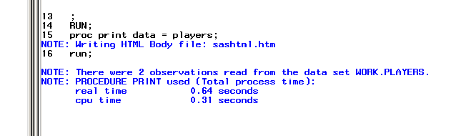

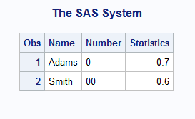

1. Identify which of the following variable name are valid SAS names:

Height- yes

HeingtInCentimeters- yes

Height_in_centimeters- yes

Wt-Kg- no

X123y456- yes

76Trombones- no

MiXedCasE- yes

1. In the following, classify each data set name as valid or invalid.

Clinic- yes

Clinic- yes

Work- yes

hyphens-in-the-name- no

123GO- no

Demographics_2006- yes

1. You have a dataset consisting of Student ID, English, History, Math and Science test scores on 10 students.
2. The number of variables is ____5_____
3. The number of observations is ____10_______
4. True or false:
5. You can place more then one SAS statement on a single line. T
6. You can use several lines for a single SAS statement. T
7. SAS has three data types: character, numeric, and integer. F
8. OPTIONS and TITLE statements are considered global statements. T
9. What is the default storage length for SAS numeric variables (in bytes)?

8 bytes if not specified otherwise.